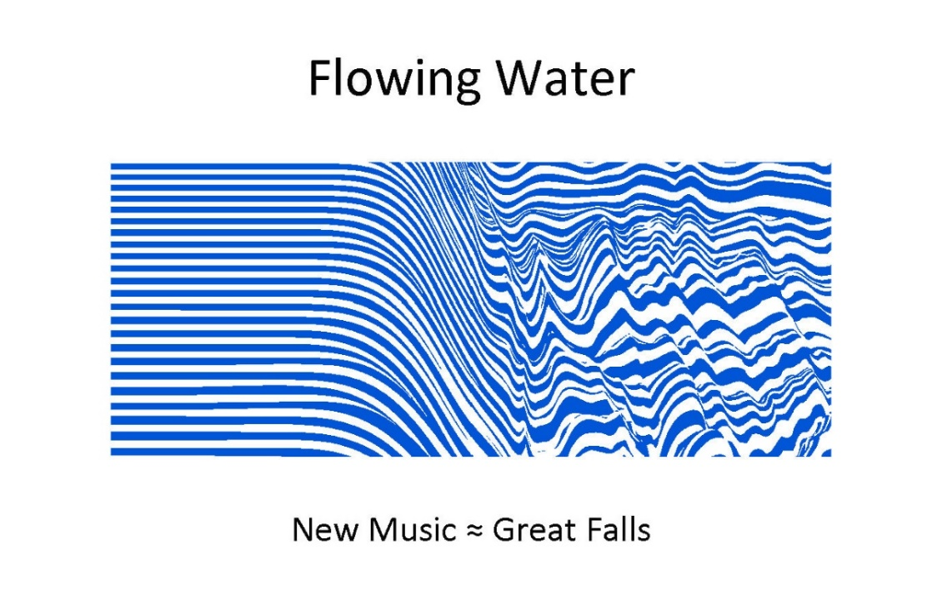
Flowing Water | New Music | Great Falls, Montana
Wednesday Afternoons | 12:05 pm
Series Three
November 27, 2024 | Jean Annau, Wendy Weissman, Clarinets  Mark Barry, Bruce Bull, Percussionists  Samarra Nicholson, Dancer  By Moonlight by Laura Detrick  Seven Dances by James F. Rickley
December 4, 2024 | Destin Markland, James F. Rickley, Pianists  17, Reawakening, Progression and Undiminished  by Destin Markland
December 11, 2024 | Alan Johnson, Soprano Saxophone  Jake Henneford, Marimba  Phenomenon by James F Rickley
December 18, 2024 | Christopher Kloker, Clarinet  Clarinificence by David Saslav  Dancing Wind, Mystic Wind, Numberings in the City of Night by James F. Rickley

New Hope Lutheran Church
3125 5th Avenue South • Great Falls, Montana
For Further Information
406-315-1203 • 406-768-8023
Bring a Lunch – Tea, Coffee, Water, Dessert Provided
Montana Composers’ Alliance Protocols
New Compositions are Performed Twice with a Q & A Between
Support Contributions to: New Hope – Concert Series

